Material Heat Lab Analysis and Clear Paragraph.
By: Rachel Lobl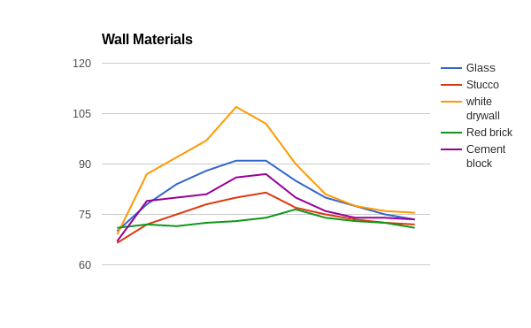
The data collected from our heat lab showed the approximate heat capacities of the materials tested. If the numbers are analyzed and show the temperature rises and fell slowly or in small increments this shows a high heat capacity ( c ). If the temperature spiked and fell rapidly then you can assume the material has a low c. High c materials tend to stay at a relatively consistent temperature like water. While, low c materials are more unpredictable and tend to spike rapidly. Low c is preferable for roofing materials because we want heat to be radiated away from the house. During our experiment it is possible the data was skewed. Most likely the cause for the inaccurate data would be the fact that we took the temperature in a different place on the material each time and that the surface area and volume of each object was different. Since the heat lamp was above the material, the heat would be more directly above the center of the material. If the the temperature was taken in the center if would have a higher temperature because more heat is hitting it. If the temperature was taken on the side, the temperature would be lower because not as much heat is hitting it. The volume and surface area is an important factor that we did not account for. Because of thermal equilibrium the heat hitting the material will spread through the material. If there is more volume, the heat will be spread thinner and therefore the overall temperature will be lower. With a lower overall volume the temperature will be spread throughout less area. Both of these factors would have affected our data. If we were to run this experiment again we would make our discrepancies constant, make our procedure more specific (add the exact place to take temp, precise volume, etc.), space out and regulate start times, test for longer ( maybe 24 hours to simulate a full day), and adjust for seasonal changes/ movement of the sun. These finding can now be used for future investigations about the effect of sun angles/ movement, changes in location, rain/ weather, texture, and color of surfaces on the performance of materials. Before running these experiments a different test would be conducted to investigate the difference in temperature reading backed on the location of the laser thermometer and its distance from the material it is testing.

Clear Paragraph
A material with a high heat capacity like brick and stucco are the ideal materials to use for walls of a house. This can be proven with an experiment where a variety of materials are put under a heat lamp for a set amount of time and the temperature recorded. Then, with the light off and observing the decrease in temperature. If the temperature rose and fell quickly then the material has a low heat capacity, it can’t hold very much heat. On the contrary, if the material’s temperature rose and fell slowly or the temperature stayed relatively consistent then the material has a high heat capacity. Brick’s temperature started at 71 degrees fahrenheit and rose (after 10 minutes under a heat lamp) to only 74 degrees. Stucco started at a lower temperature at 66.5 degrees fahrenheit and under the same conditions rose to 81.5 degrees. The temperature rose more but not enough to be considered uncomfortable or having a low heat capacity. On the other hand materials like white drywall started at 69 degrees fahrenheit and rose to 102. However, quickly cooled back down to 81 in only 4 minutes without the heat lamp. It is apparent that drywall has a low heat capacity. If a wall was made out of a material with a low heat capacity, the wall would burn them during the day and freeze over during the night which is not ideal. Heat capacity relates to the amount of heat energy it takes to raise the temperature of an object. It is important for walls to be able to absorb that energy to keep the house warm but relase enough to not because uncomfortable. High heat capacity materials do this. Brick, stucco, and cement are ideal for walls in housing because they stay at an almost constant temperature which will mean they won’t burn or freeze. Other high heat capacity material would also be appropriate.

